TROUBLESHOOTING ONEDRIVE EXPLORER FAILED TO SYNC

## SYMPTOMS

* When user sign into OneDrive, error: **“Sorry, OneDrive can’t add your folder right now”**
* 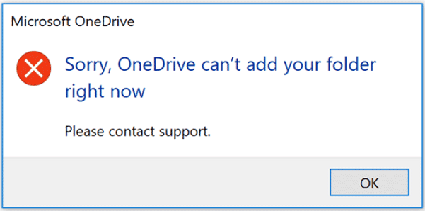
* **Policy Noncompliant:** 
  + **for system:** Limit the sync app upload rate to a percentage of throughput-Noncompliant
  + **for system:** Prompt users when they delete multiple OneDrive files on their local computer-Noncompliant
  + **for system:** Silently move Windows known folders to OneDrive-Noncompliant
  + **for User:** there is no Noncompliant, or Conflict.

## CAUSE

Onedrive.exe is not allowed to sync in Azure AD. Current Configuration Setting, only allowed sync to 2 AD Domain ID as shown here:

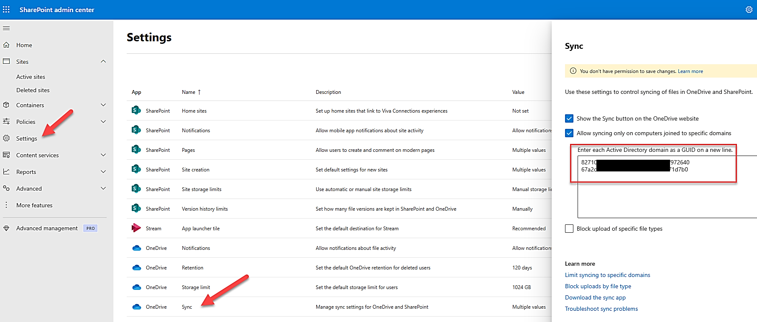

## SOLUTION

Uncheck the box: Allow Syncing only on computers joined to specific domains.

Make sure conditional access grant to the Cloud App O365 with condition of MFA and Device Compliant.

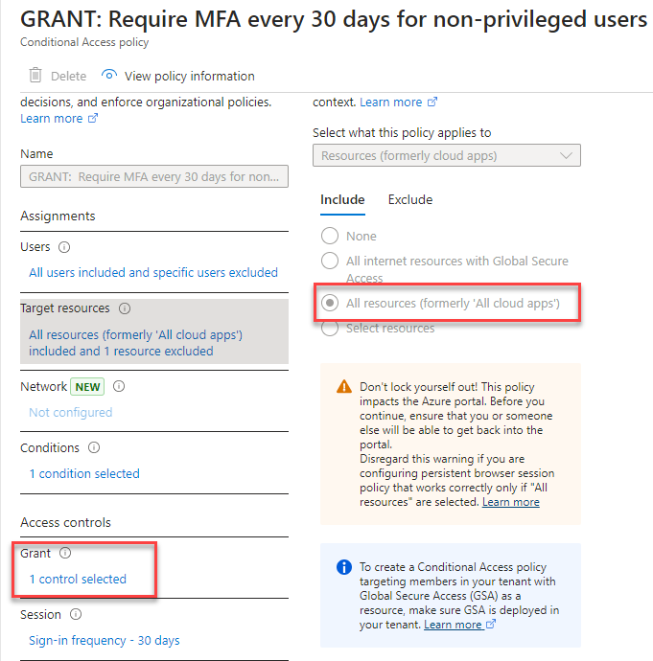

The Grant Selection:

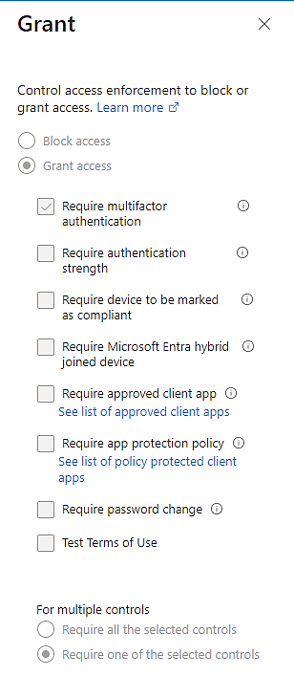

Or

### Using the work around,

1. Adding the Azure Tenant ID of your Company, 8b24586x-xxxx-xxxx-xxxx-xxxx083f43d6, to the SharePoint Allow Syncing Domain List.
2. On the Windows Devices who enrolled in Intune, adding the registry:

*HKEY_LOCAL_MACHINE\Software\Policies\Microsoft\OneDrive*

*AADJMachineDomainGuid , SZ, value:* 8b24586x-xxxx-xxxx-xxxx-xxxx083f43d6